**CPU Order Search Website User Guide**

May 2016

*Version 1.0*

1. **Introduction**

**1.1 Scope and Purpose**

This website to provides the information of CPU of current sale, information of customers who registered at this store and information of orders which were from the registered customers. These information could be fetched both independently and combined. The combined search only displays the information that could match relationship between two or three of the entities(CPU, customer, order). The purpose of this website is to let users allocate the information of sale quickly.

**1.2 Workflow Overview**

To use this website, firstly, user selects the field that is/are interested in. Then the add optional conditions in one or more fields of CPU name, CPU speed and RAM frequency. When the user wants to clear all previous setting, **click** the "Reset" button. When lift click "Submit" button, the website will check the feasible of this search and provide alert box indicating the accordingly error. Otherwise, the information matching the search will be returned from the server database.

1. 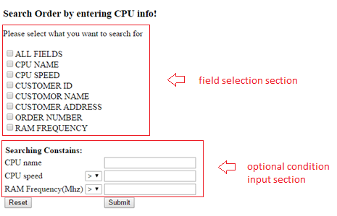**Workflow**

***Figure 1***

***Figure 1*** shows the user interface of this website. There are 2 main sections: field selection section and optional condition input section. Field selection section is **required** to select. The search result will show the selected fields accordingly. The optional condition input section is used to let the user input some additional condition in the search.

**2.1 Step 1: field selection**

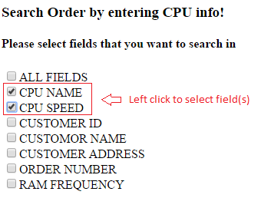

***Figure 2***

To select field(s), just **check** the checkbox like showing in ***Figure 2***. User can select multiple fields, either by selecting "ALL FIELDS" or by selecting each individual field of interests. When selecting both "ALL FIELDS" and any other fields, the website default logic sets "ALL FIELDS" with higher priority, thus, the returned result will have all other fields on the field select section.

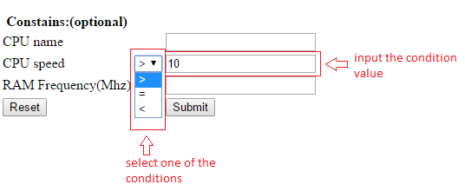**2.2 Step 2: condition input**

***Figure 3***

This step is optional. The purpose of this step is to refine the search to get more accurate result. There are three optional condition that can be used as shown in ***Figure 3***. "CPU name" field can be used if the user know the CPU's name and wants to search only information about this CPU. "CPU speed" and "RAM Frequency(Mhz)" field can be used if the user wants to show result according to a certain range of CPU speed and/or RAM frequency. Each of this two fields has 3 types of condition associating with the input value initially as ">"(less than). As an instance shown in ***Figure 3***, this combination means that the condition is set to "given CPU speed is less than 10".

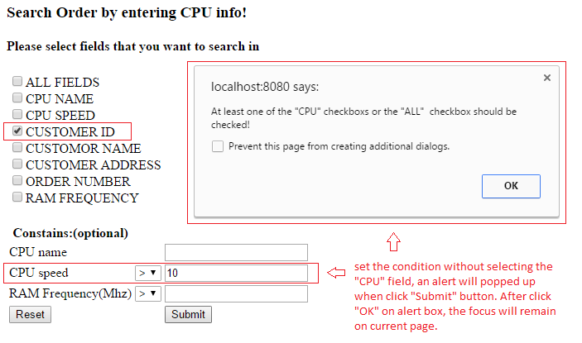When the user selects to use optional condition to refine the search however does not select the either one of the CPU field("CPU NAME", "CPU SPEED") or "ALL FIELDS" in the field selection section, there is an alert box popping up when **click** "Submit" button, indicating that at least one of these fields should be checked and the focus will remain the current page, as shown in ***Figure 4***.

***Figure 4***

**2.2 Step 3: Reset or Submit query to view results**

**Reset**: If there are multiple portion of this search need to be modified, the user could easily **click** "Reset" button to clear all the previous settings and selections, and start from the beginning(refer to step 1).

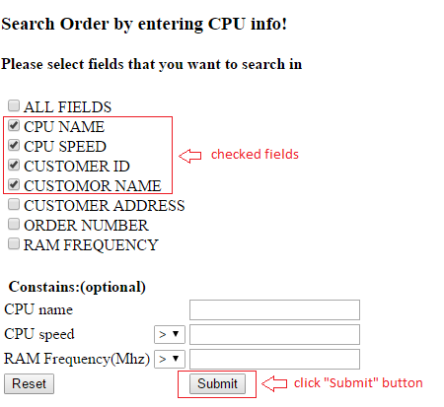**Submit**: When the user feel safe to perform the query, **click** "Submit" button. The server side program will return a new page with searching result as shown in ***Figure 5(a)(b)***.

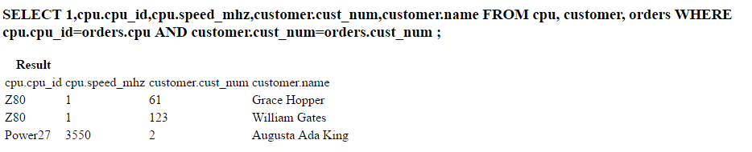***(a) User Interface Page***

***(b) Search Result Return Page***

***Figure 5***

1. **Appendices**

**3.1 Platform**

This website has been tested on desktop version browsers:

|  |  |
| --- | --- |
| Google Chrome | Version 50.0.2661.94 m |
| Mozilla Firefox | 45.0 |
| Microsoft Edge | 25.10586.0.0 |
| Mac OS Safari | 9.1 |

**3.2 Issues and Bugs**

1) Logic issue: some redundancy in server side PHP program. These could be solved in the further version, using JavaScript in the User Interface Page to check the logic initially.

2) Efficiency of use: this query could be dynamic. This could be solved in the further version, using AJAX.